

MOUNT KENYA UNIVERSITY

SCHOOL OF COMPUTING AND INFORMATICS
DEPARTMENT OF INFORMATION TECHNOLOGY
HUMAN MATRIX SYSTEM
Name: MAXWELL WAIME
Reg: BSCCS/2024/59239

Lecturer: Michael Nyoro

This project is submitted in partial fulfillment of requirement for the Mount Kenya University award of
BACHELOR OF SCIENCE IN COMPUTER SCIENCE
MAY/AUG 2026

Table of Contents
Week 1 3
Installation and Testing of Local Development Environment 3
Reflection 6
Week 2 7
User Interface Planning and System Design 7
Week 3 8
Javascript and Php basics 8
Reflection 10
Week 4 10
GitHub 10
Figure 12: Upload to Github 10
10
Frontend Interaction and Backend Foundations 11
Reflection 11

Week 1

Installation and Testing of Local Development Environment
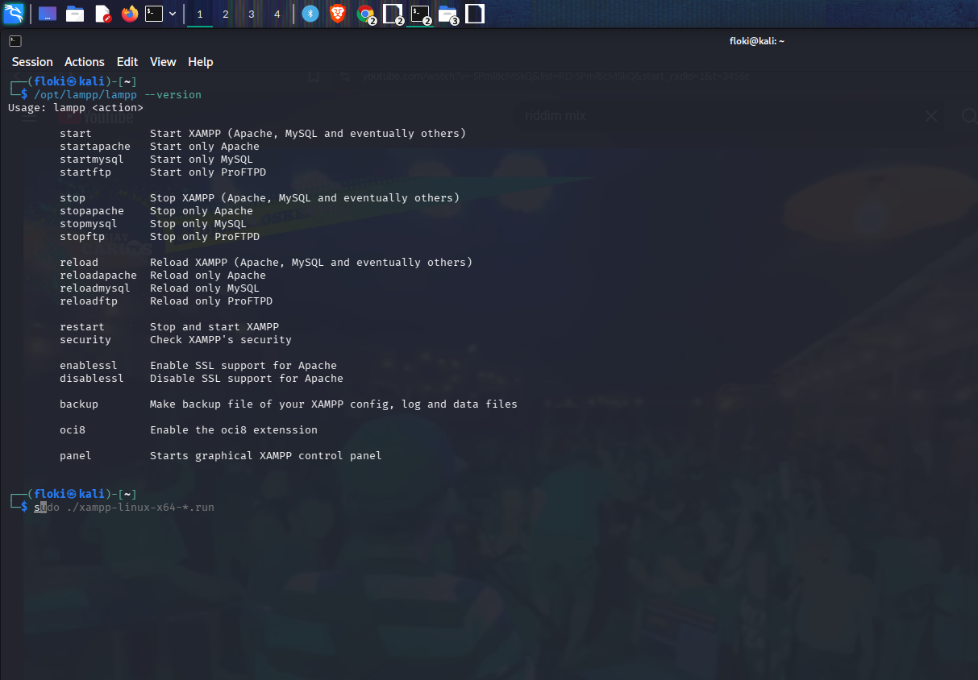
Figure 1: Xampp server logs
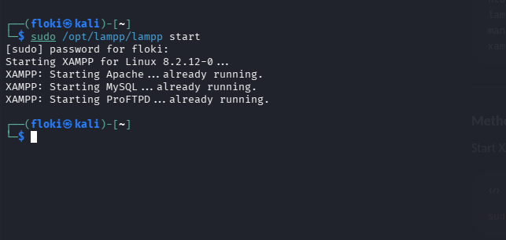

Figure 2 Xampp server control
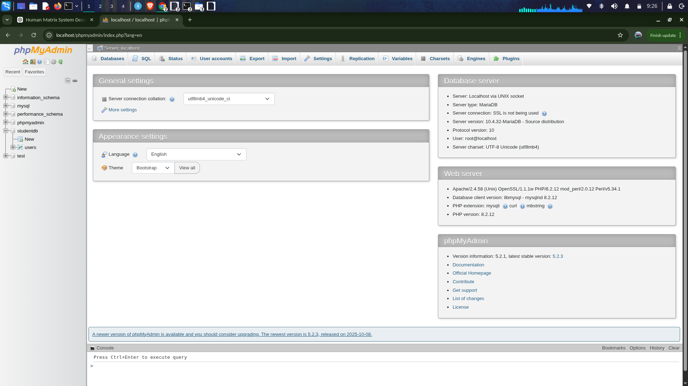

Figure 3: Xampp Dashboard
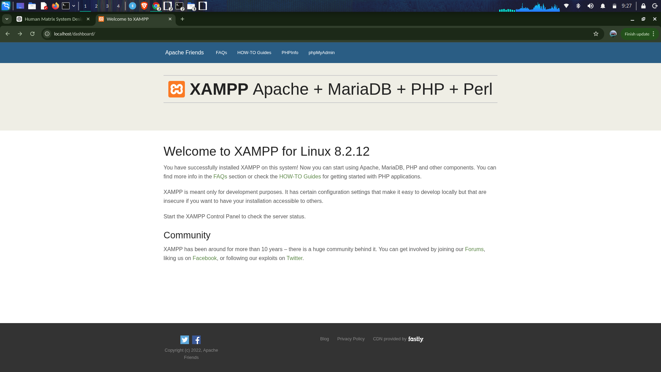

Figure 4: Hello world



Figure 5:HumanMatrix Project Structure

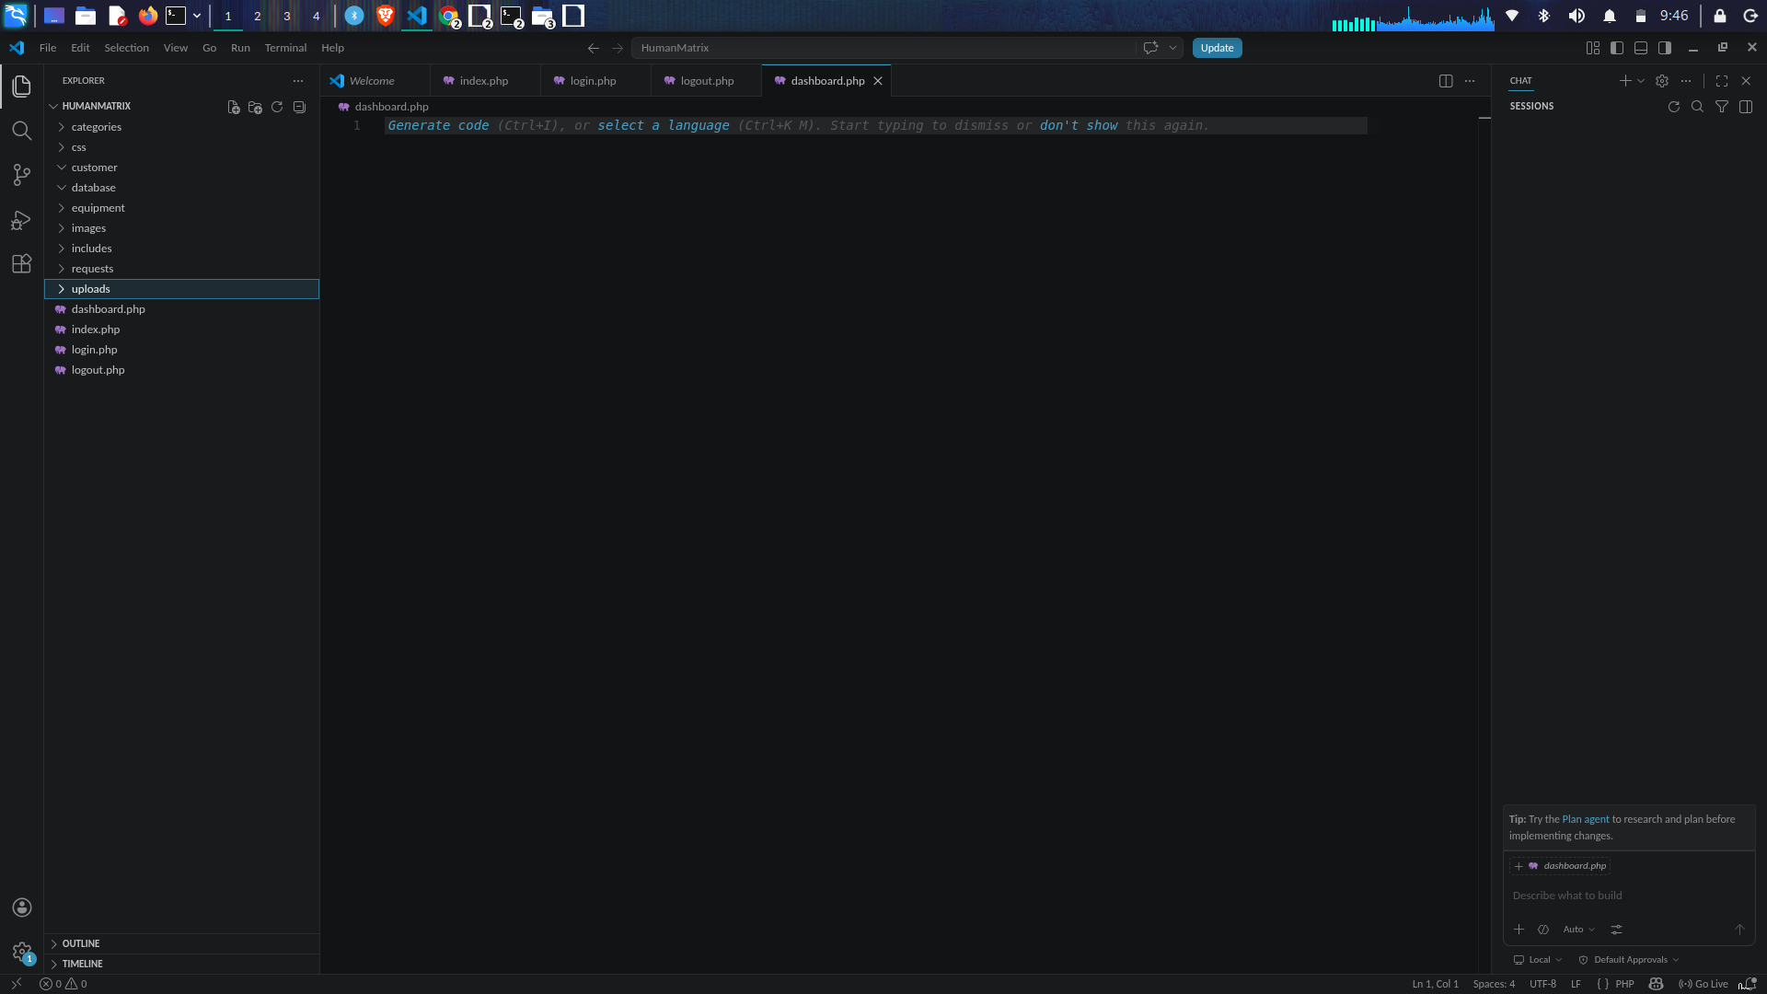
Figure 6: PhpMyAdmin
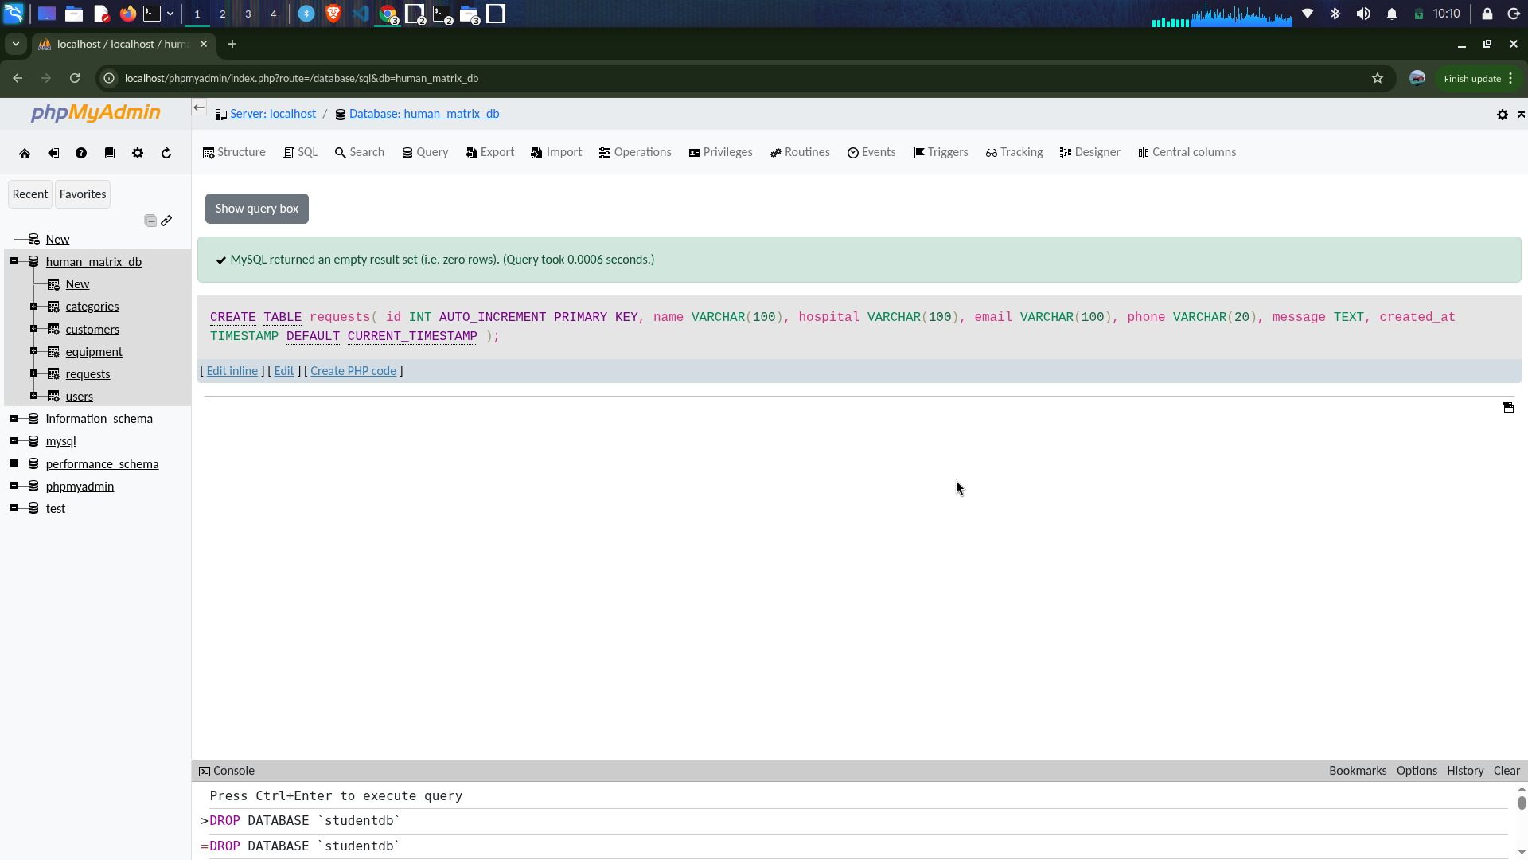

Reflection
Fig 6 shows successful connection between PHP and MySQL using mysqli_connect() with localhost, root user, and HumanMatrix database. This confirmed that Apache and MySQL services were properly configured in XAMPP.

Week 2

User Interface Planning and System Design
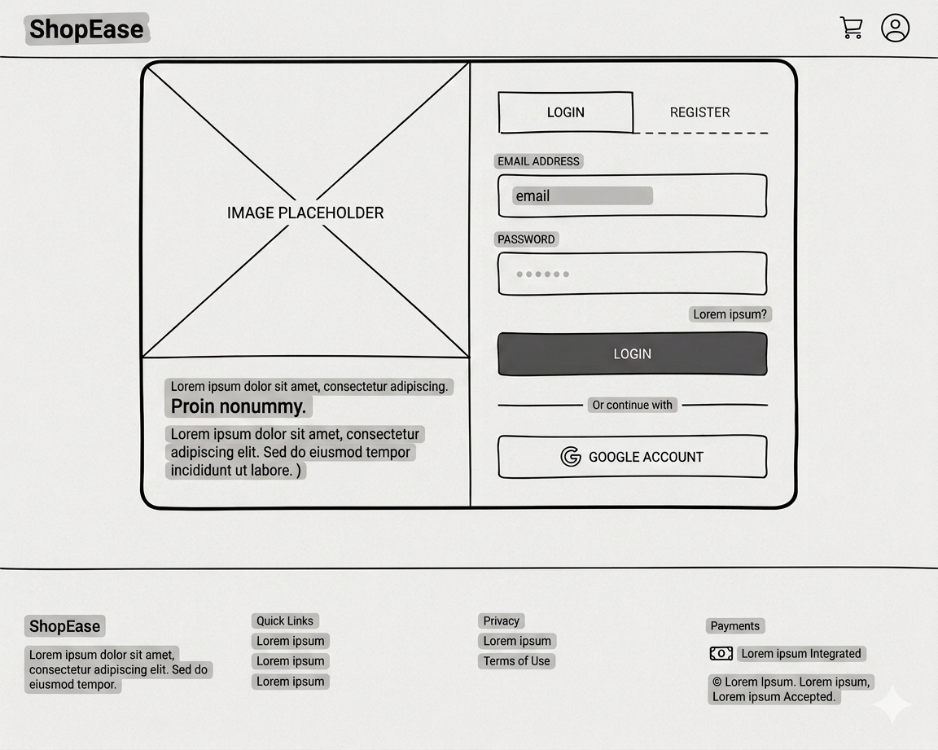

Week 3

Javascript and Php basics
Figure 7: Login Wireframe
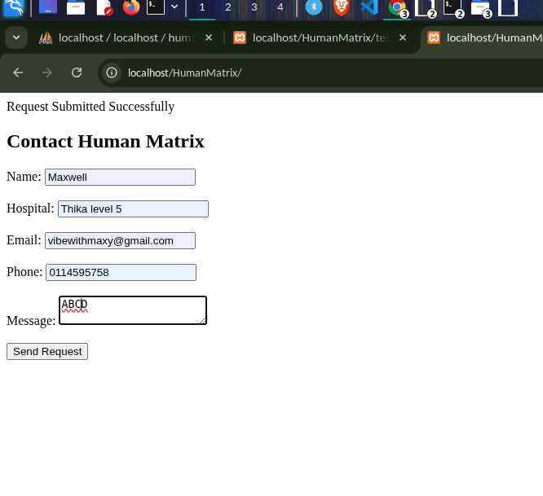
Figure 8: Dashboard Layout
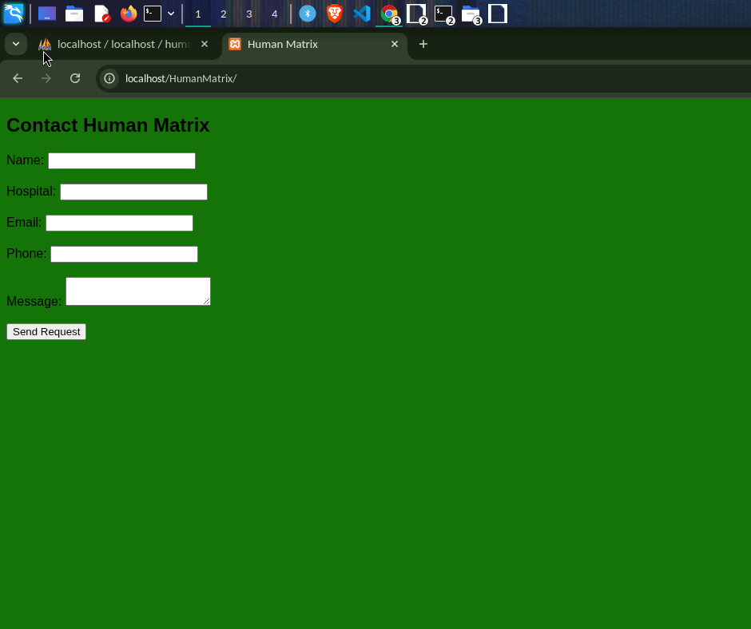Figure 9: Dashboard Mobile Layout

Figure 10: Theme


Figure 11: Project Figma

Reflection
I selected a green primary color to represent trust, reliability, and growth within the medical equipment industry, while white accents were used for buttons and important actions to improve visibility and create a clear visual hierarchy. The interface was designed with simplicity and usability in mind, ensuring that administrators can easily manage equipment, customers, and requests. The layout is also responsive, allowing the system to adapt effectively to different screen sizes.

Week 4

GitHub

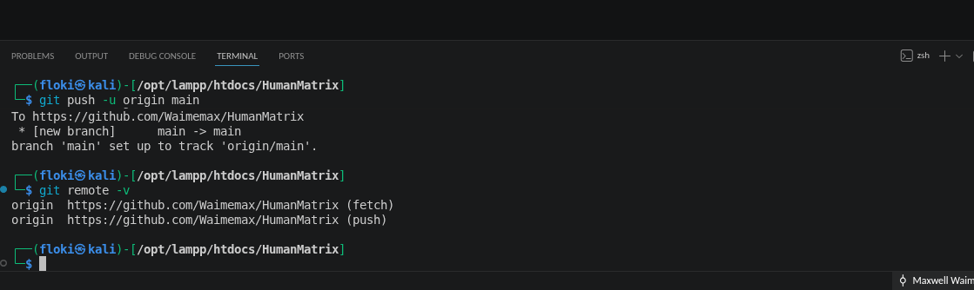

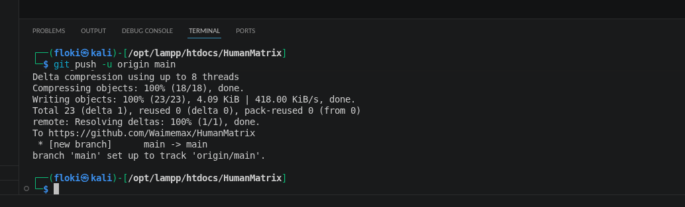

Figure 12: Uploading HumanMatrix to Github

Frontend Interaction and Backend Foundations

Figure 13: Form Validation

Figure 14: email check

Reflection
I enhanced my understanding of backend web development using PHP. I learned the importance of organizing project files in a professional structure, which improves maintainability and scalability of web applications.

